From 7/5/15

Hi Matt,

this week I did my first wind measurements with the dataduino during a windy day (total one hour measurement with 1 min interval). The wind logger worked fine!

I tried to calibrate one of the cheap Maplin anemometer with an expensive (calibrated) Davis anemometer and find a big scatter, do you recognize this "trend"?:

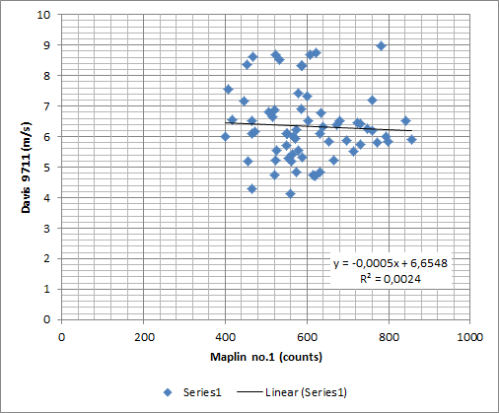

When I have more time again I will gather more data and will test two Maplin anemometers in parallel so I can also measure the difference between them.

keep you posted,

kind regards,

Marko Bosman

From 18/5/15:

(attached pdf)

Hi Matt,

I did some more measurements and got fairly accurate results now; see attachment. (note that the picture I have send before was wrong due to shift of time scales)

The measurement at very low windspeeds (<1 m/s) have been excluded from the dataset because the Davis anemometer is not very accurate at low wind speeds and for the purpose of wind turbine site measurements these data are not very relevant. I miss some data between 3-4 m/s, but the low and high wind speed measurements seems to correlate well. The final formula for calculating windspeed from the counts registered by the windlogger was for Anemometer 1: 0,57m/s per Hz and for Anemometer 2: 0,63m/s per Hz, somewhat different as the 0,7m/s per Hz you mentioned, but I think every Maplin anemometer is different and should be measured (periodically?).

What do you think about this procedure?

Kind regards,

Marko

From 20/5/15

(attached additional pdf)

Hi Matt,

I continued my calibration activities and finished it for 4 maplin anemometers, see attachment.

the results are pretty constant, but differ from your formula:

* Anemometer  1: 0,58 **m/s per Hz**
* Anemometer  2: **0,62 m/s per Hz**
* Anemometer  3: 0,62 **m/s per Hz**
* Anemometer  4: **0,61 m/s per Hz**

**regards,**

**Marko**